Question 5
5.1. – Peer Evaluation
1. Rueben Slingerland
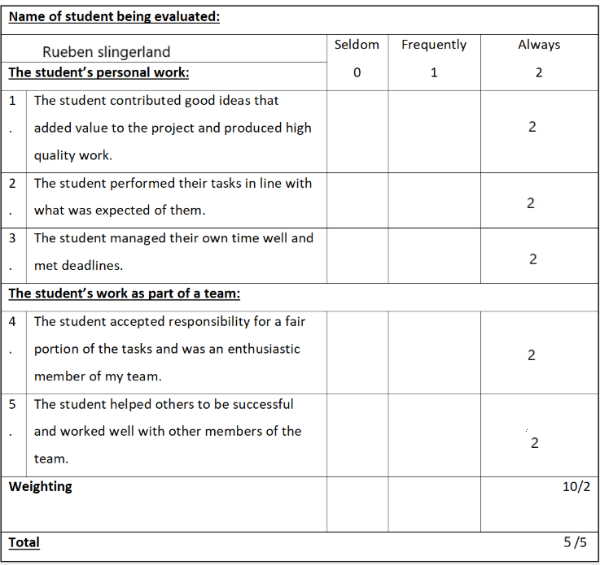

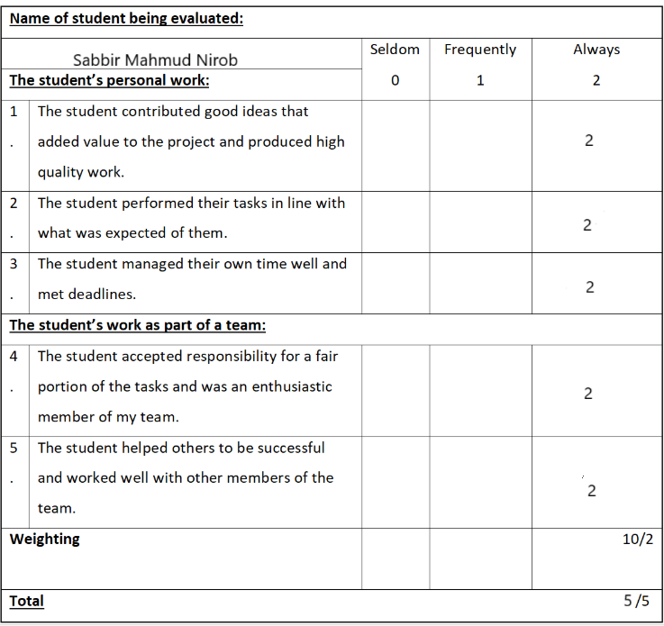
2. Sabbir Mahmud Nirob

3. Utima Emerson Neto
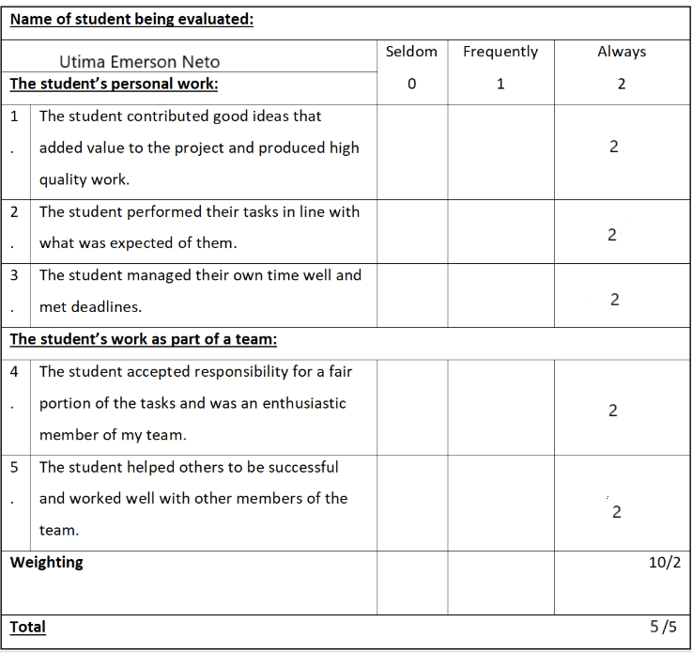

5.2 - Self-Reflection Report
Introduction
The HealthLink project focused on creating a cross-platform health and wellness app that gives users access to trusted medical information and resources. The goal of this assignment was to apply what we’ve learned about project management, teamwork, and technical skills in a real-world project. Through this experience, I learned how important good communication, planning, and collaboration are when developing an IT project from start to finish.
Technical Skills:
Throughout the project, I strengthened my research and technical abilities. I learned to work with frameworks like .NET MAUI for cross-platform app development and used data organization techniques to structure our project documentation. I also became better at identifying credible online sources and referencing them properly. These skills made our design choices more informed and realistic from a technical point of view.
Communication and Teamwork Skills:
Being part of the IS Insiders team helped me grow in communication and teamwork. We used shared Word documents and online meetings to share ideas, assign tasks, and give feedback. Our discussions encouraged creativity and kept everyone working toward the same goals. I also learned to listen carefully, value different opinions, and contribute positively during group sessions.
Management Skills:
Time management and problem solving played a big role in this project. We had to meet multiple deadlines while managing other responsibilities. I learned how to prioritize tasks, track progress, and stay organized using digital tools. When issues came up such as uncertainty around task roles, I helped clarify responsibilities and suggest practical solutions, which kept the team focused and on track.
Role in the Team:
My main role was to contribute to research, write parts of the report, and review formatting and referencing. I also helped summarize group discussions and present our findings clearly. I made sure to follow the guidance of our team leader while also taking initiative when planning our next steps. When disagreements came up, I encouraged open discussions and made sure that everyone’s opinion was heard before we made a final decision.
Research and Technology:
Research played a key role in our project. I explored different cross platform development tools and their advantages for healthcare applications. I also investigated project evaluation methods to understand how success could be measured. To collect information, I used sources such as Microsoft Learn, Cognitiv, and Netguru blogs. Our team worked together through Microsoft Word, Teams, and shared online folders, which made it easier to combine our work and stay organised.

Personal Strengths and Weaknesses:
During this project, I recognized several strengths, including adaptability, teamwork, critical thinking, and attention to detail. I was consistent in meeting deadlines and ensuring that all written work was clear and well-structured. However, I noticed some weaknesses, such as sometimes focusing too much on formatting and minor details, which slowed my progress. I also found it challenging to delegate tasks early on. To improve, I plan to manage my time better and trust my teammates’ contributions more.
Stakeholder Relationships:
Our team collaborated well and maintained positive communication with the lecturer. Everyone respected deadlines and provided feedback in a constructive way. The success of our teamwork came from open communication and shared accountability. In future projects, I aim to strengthen these relationships by offering more proactive feedback and encouraging earlier reviews of tasks.
Impact:
My contributions added value by ensuring that research sections were accurate, cohesive, and properly referenced. I also helped improve the overall presentation and structure of the project report. In future projects, I can have an even greater impact by taking a more active leadership role and guiding the team through planning stages.
Conclusion:
Overall, the HealthLink project was a valuable learning experience that strengthened my technical, communication, and management skills. I learned how to collaborate effectively in a professional team setting, apply research to real-world applications, and manage time under pressure. The project improved my confidence in handling group work and prepared me for future challenges in the IT field.

